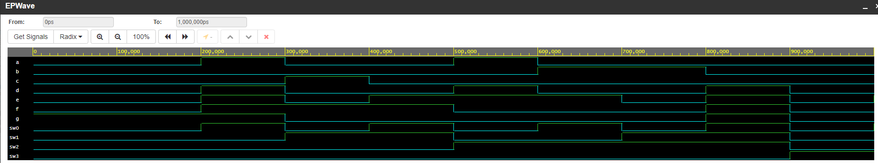

| A | B | C | D | a | b | c | d | e | f | g | # |
| --- | --- | --- | --- | --- | --- | --- | --- | --- | --- | --- | --- |
| 0 | 0 | 0 | 0 | 0 | 0 | 0 | 0 | 0 | 0 | 1 | 0 |
| 0 | 0 | 0 | 1 | 1 | 0 | 0 | 1 | 1 | 1 | 1 | 1 |
| 0 | 0 | 1 | 0 | 0 | 0 | 1 | 0 | 0 | 1 | 0 | 2 |
| 0 | 0 | 1 | 1 | 0 | 0 | 0 | 0 | 1 | 1 | 0 | 3 |
| 0 | 1 | 0 | 0 | 1 | 0 | 0 | 1 | 1 | 0 | 0 | 4 |
| 0 | 1 | 0 | 1 | 0 | 1 | 0 | 0 | 1 | 0 | 0 | 5 |
| 0 | 1 | 1 | 0 | 0 | 1 | 0 | 0 | 0 | 0 | 0 | 6 |
| 0 | 1 | 1 | 1 | 0 | 0 | 0 | 1 | 1 | 1 | 1 | 7 |
| 1 | 0 | 0 | 0 | 0 | 0 | 0 | 0 | 0 | 0 | 0 | 8 |
| 1 | 0 | 0 | 1 | 0 | 0 | 0 | 0 | 1 | 0 | 0 | 9 |

a = F1 (A, B, C, D) = m (0, 2, 3, 5, 7, 8, 9)

b = F2 (A, B, C, D) = m (0, 1, 2, 3, 4, 7, 8, 9)

c = F3 (A, B, C, D) = m (0, 1, 3, 4, 5, 6, 7, 8, 9)

d = F4 (A, B, C, D) = m (0, 2, 3, 5, 6, 8)

e = F5 (A, B, C, D) = m (0, 2, 6, 8)

f = F6 (A, B, C, D) = m (0, 4, 5, 6, 8, 9)

g = F7 (A, B, C, D) = m (2, 3, 4, 5, 6, 8, 9)

For this schematic, we have a decoder with a 4 bit input because our range of numbers is from 0 to 9 requiring 10 digits, which is 1010 in binary at most. Since there are 9 digits and a 16 number range, we can correlate each display state to a 4 bit binary number which would result in our desired output of a specific digit on a 7 segment digital display

